STATE OF
Portuguese Digital Accessibility
2026, Inaugural Edition
Automated audit of 160 Portuguese consumer-facing digital services across eight sectors, run between 22 and 24 April 2026 against the European Accessibility Act.
Published by accessibilityref.eu
Scan period: 22–24 April 2026
Methodology: cheerio + agent-browser (Chrome) + axe-core 4.10 + Article 13 statement classifier
All site identities are anonymised in this report.

Executive summary
In April 2026, ten months after the European Accessibility Act became enforceable across the EU, accessibilityref.eu audited 160 Portuguese consumer-facing digital services using automated structural and rendered-DOM testing. The sample covered eight sectors with twenty sites each: banking, public sector, healthcare and insurance, telecoms and media, travel and transport, e-commerce, sport and culture, and utilities. Sites were selected as the largest and most-used Portuguese services within each category.
Only twenty-four of the 160 sites in scope met or exceeded the threshold for an A or B grade. Ninety-two had no detectable accessibility statement, which is a baseline requirement under Article 13 of the EAA transposition. A further thirty could not be reached by a standard audit request.
The findings are aggregate. No company is named, and individual results are not published; the data does not establish legal non-compliance for any specific entity. The report characterises the state of one sector as it adapts to a new legal obligation, and flags where consumer complaints and regulator attention are most likely in the months ahead.

Headline numbers
Sites in audit scope (8 sectors × 20 sites) | 160
Sites achieving Grade A (16+/20) | 8
Sites achieving a passing grade (≥10/20) | 64 (40%)
Sites with a fully compliant accessibility statement | 20
Sites with no detectable accessibility statement | 92
Sites unreachable by automated audit | 30
Sites using third-party "accessibility overlay" widgets | 10
Mean composite score across reachable sites | 9.74/20
A passing grade in this report is the structural and statement-level baseline of EAA conformance, nothing more. Even sites in the A band carry residual issues that a manual conformance audit would catch. Passing here is the floor.

Methodology
The audit used three layers of automated testing, scoped to what can be observed without authentication or private-account interaction. It therefore captures the public-facing experience of each service: what a first-time visitor encounters, including a visitor relying on assistive technology.

What was tested
- Structural HTML inspection via cheerio: page language declaration, viewport meta tag, skip-to-content link, <main> landmark presence, heading hierarchy, image alt attribute coverage, form field labelling, and cookie banner accessibility signals.
- Rendered DOM accessibility audit via axe-core 4.10 running inside a real browser (Chrome). axe-core runs the full WCAG 2.1 A and AA ruleset plus best-practice checks against the post-render DOM.
- Accessibility statement detection and classification: each site was probed at six common conventional URLs for an Article 13-style accessibility statement, and the recovered statement was scored against eleven required markers (conformity claim, WCAG reference, EN 301 549 reference, A/AA level declaration, scope, date, feedback channel, contact email, declaration of inaccessible parts, Article 29 reference, and the named regulator).
- Overlay widget detection: third-party "accessibility overlay" vendor scripts were detected via known DOM signatures and recorded as a separate signal. They do not count toward conformance.

Composite scoring
Each site was assessed against a 20-point binary scoring system spread across four dimensions:
- Structural accessibility (8 points): one point per structural check passed.
- Accessibility statement (4 points): four points for a full Article 13 statement, two for a partial statement, one for a marketing claim only, zero for none or for overlay-vendor boilerplate.
- axe-core findings (5 points): one point each for: zero critical violations, fewer than five critical-plus-serious violations, zero colour-contrast issues, zero image-alt issues, zero link-name issues.
- EAA compliance signals (3 points): one point each for: no overlay widget present, EAA signals detected in markup, accessibility links present in navigation.
Composite score is mapped to a five-grade scale:
- Grade A: 16–20 (strong baseline conformance)
- Grade B: 13–15 (substantial conformance with material gaps)
- Grade C: 10–12 (passing baseline but multiple weak areas)
- Grade D: 7–9 (substantial non-conformance)
- Grade F: 0–6 (negligible accessibility provision)
- Not reachable: site could not be retrieved by automated audit (bot wall, geoblock, fetch error).

What this audit does not test
This audit is not a manual accessibility conformance evaluation. It does not test authenticated user flows, screen reader narration quality, the full transactional path (checkout, booking, account management), keyboard-only journey completion, video caption quality, or PDF document accessibility. A site scoring well here may still fail a full manual audit, and a site scoring poorly here will almost certainly fail one. The findings should be read as a sector-level signal, not as a definitive statement on any individual site.
This is a self-assessment tooling exercise. Under the European Accessibility Act, businesses self-assess and publish accessibility statements; regulators investigate reactively. This report describes the public evidence of that self-assessment work across one national market.

Findings

1. Composite score distribution
Of the 160 sites audited, 64 (40%) reached a passing composite grade of C or higher. Only 8 reached Grade A. The largest grade band was D, substantial non-conformance. A further 30 sites could not be reached by the automated audit at all, which is itself an accessibility concern: infrastructure that blocks accessibility tooling typically also impairs assistive technology.
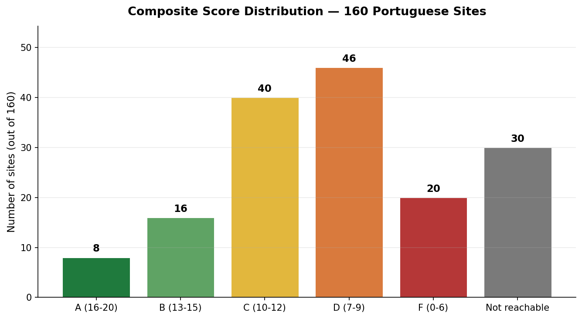

2. Mean score by sector
Sector-level performance is uneven. Banking and Public Sector clear the passing threshold of 10/20; the remaining six sectors do not. Travel & Transport, E-commerce, and Telecoms & Media cluster within 0.1 points of one another at 9.5/20, which suggests a similar baseline of partial structural compliance without statement-level effort.
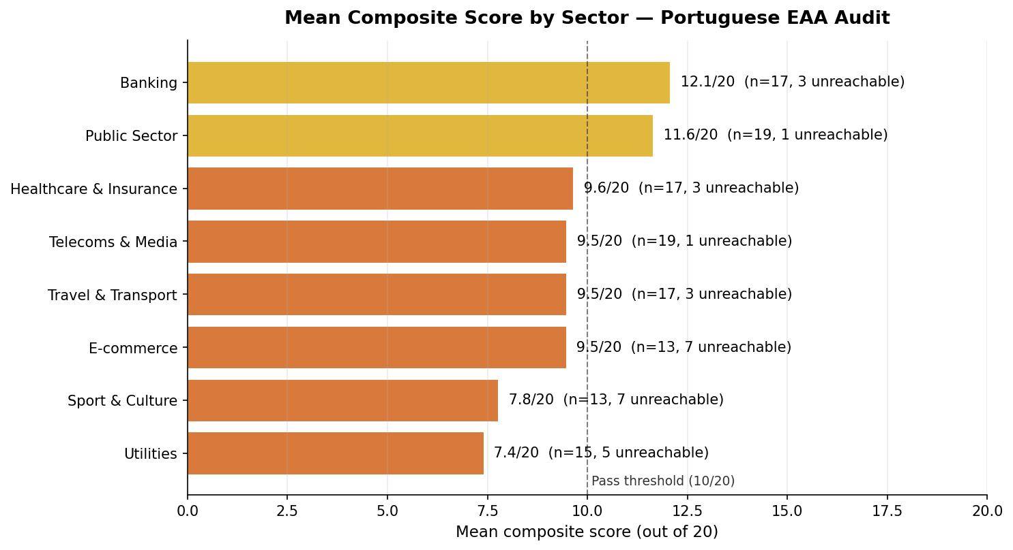

3. Grade distribution within each sector
No sector is uniform. Even the lowest-mean sectors include individual high performers; even Banking, the strongest-mean sector, contains sites scoring in the F band. The dispersion suggests EAA compliance is currently driven by individual organisational priorities rather than sector-wide standards or peer pressure.
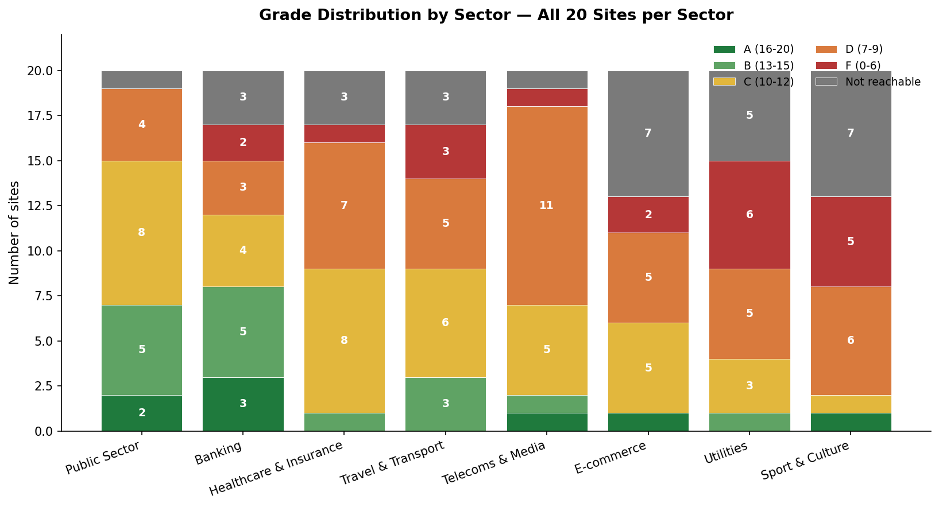
The sector-by-sector aggregate is summarised below:
Sector | Mean score | Sites scored | Sites unreachable
Banking | 12.06/20 | 17 | 3
Public Sector | 11.63/20 | 19 | 1
Healthcare & Insurance | 9.65/20 | 17 | 3
Telecoms & Media | 9.47/20 | 19 | 1
Travel & Transport | 9.47/20 | 17 | 3
E-commerce | 9.46/20 | 13 | 7
Sport & Culture | 7.77/20 | 13 | 7
Utilities | 7.4/20 | 15 | 5

4. Accessibility statements: the single largest gap
The largest gap in the dataset is the near-absence of compliant Article 13 accessibility statements. Of 160 sites, only 20 (13%) published a statement that met the substantive markers required by the EAA transposition. 92 sites (58%) published no statement at all, neither at conventional URLs (/acessibilidade, /accessibility, /declaracao-de-acessibilidade) nor in their footer navigation.
A further nine sites published only the boilerplate statement injected by a third-party accessibility overlay vendor. These do not satisfy Article 13: they describe the overlay's claimed remediation rather than the site's actual conformance position, and they do not name the responsible regulator or the feedback mechanism that the law requires.
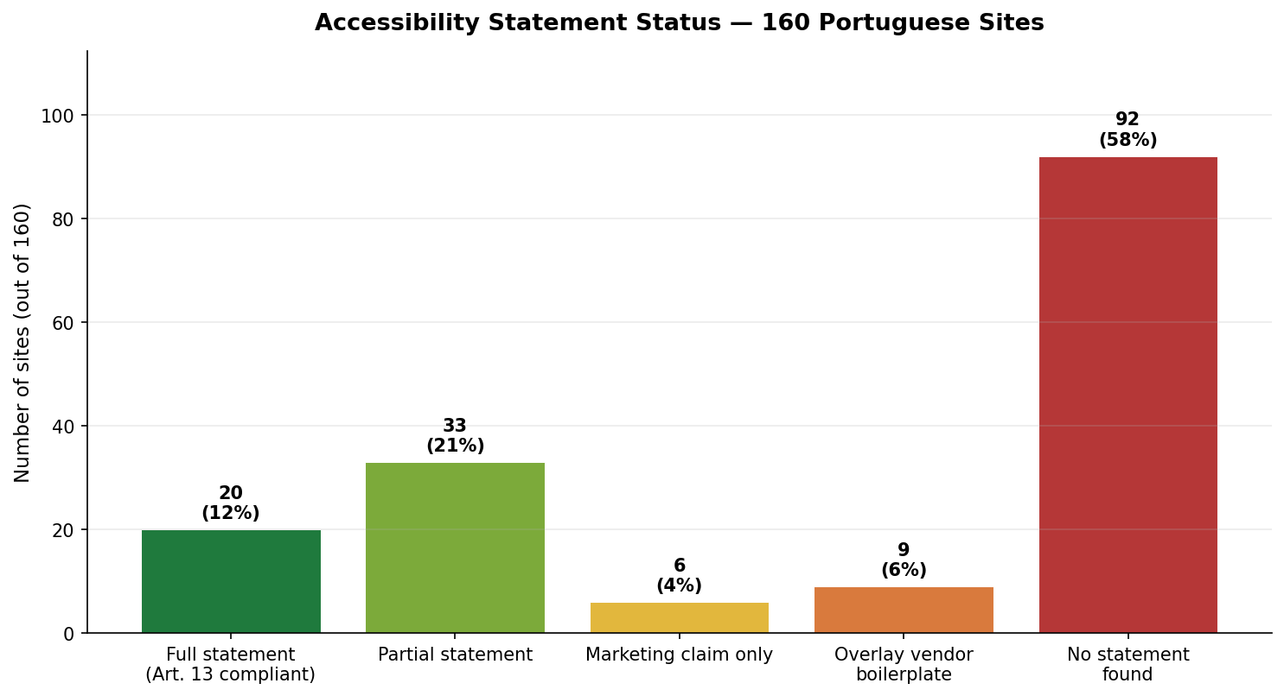
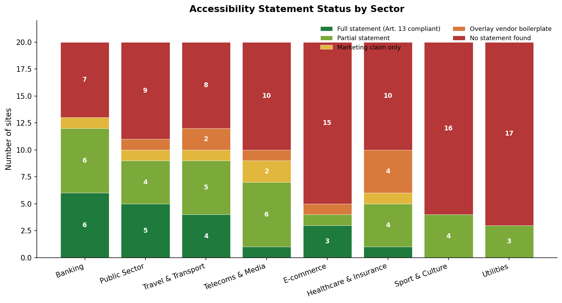
Producing an accessibility statement is mechanically the easiest part of EAA compliance: a written declaration following a published template. That 58% of sites have not produced one indicates EAA awareness has not yet reached the operational level inside most organisations.

5. Structural pass rates
Eight structural HTML accessibility checks were applied to every site. Pass rates varied widely. Mobile viewport and language declaration both reach high pass rates because modern web frameworks set them by default. The lower-scoring checks (heading order, skip links, and accessible cookie banners) fail because they require deliberate accessibility intent rather than framework defaults.
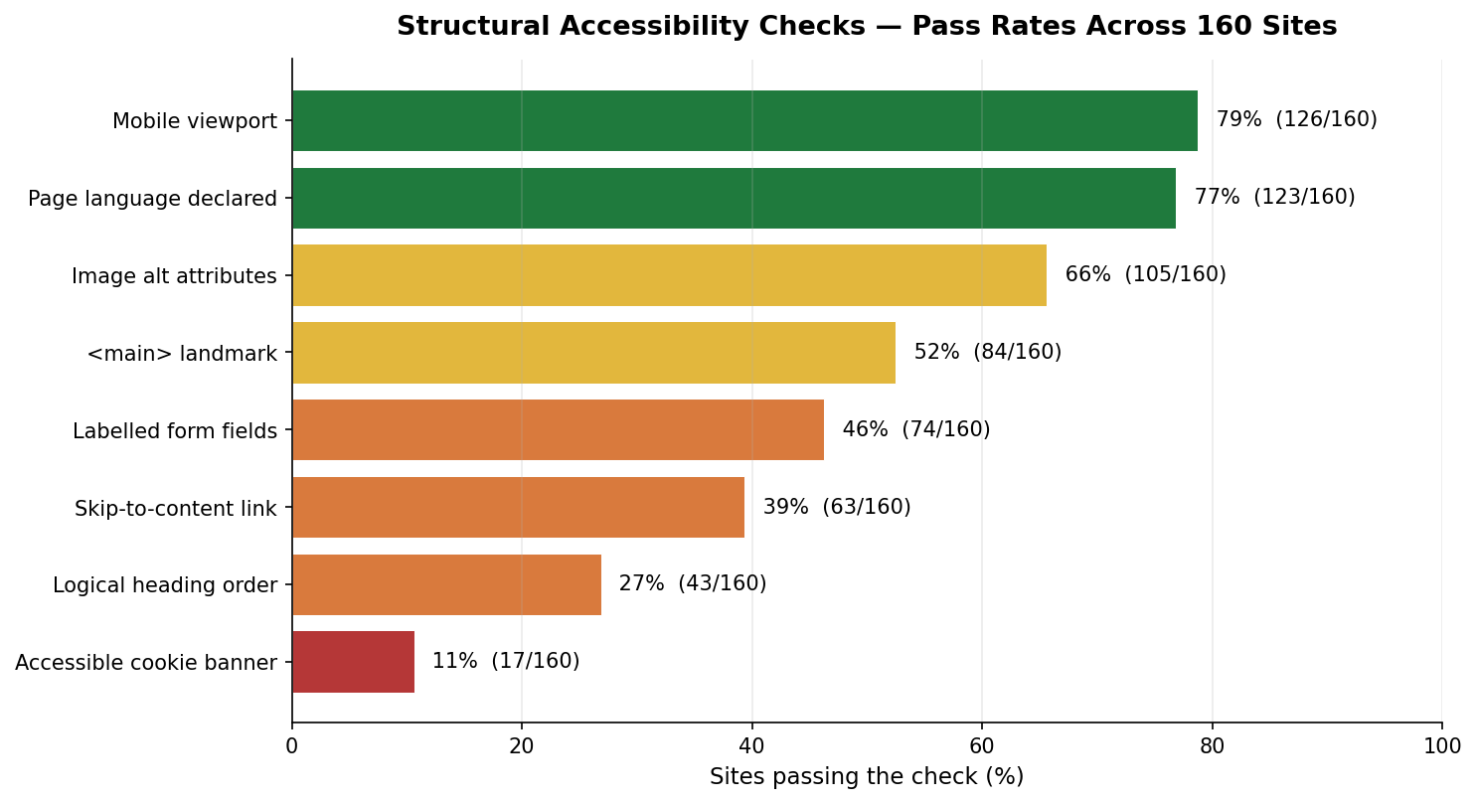
The cookie banner result is worth pulling out. Only 11% of sites passed the cookie banner accessibility check. No consumer can use a Portuguese commercial site without first interacting with a cookie banner, so an inaccessible banner is a complete blocker for users relying on assistive technology, regardless of how accessible the rest of the site is.

6. Top automated (axe-core) violations
Across the 118 sites where the rendered DOM was successfully captured, axe-core flagged thousands of individual violations. Three violation types account for most of them:
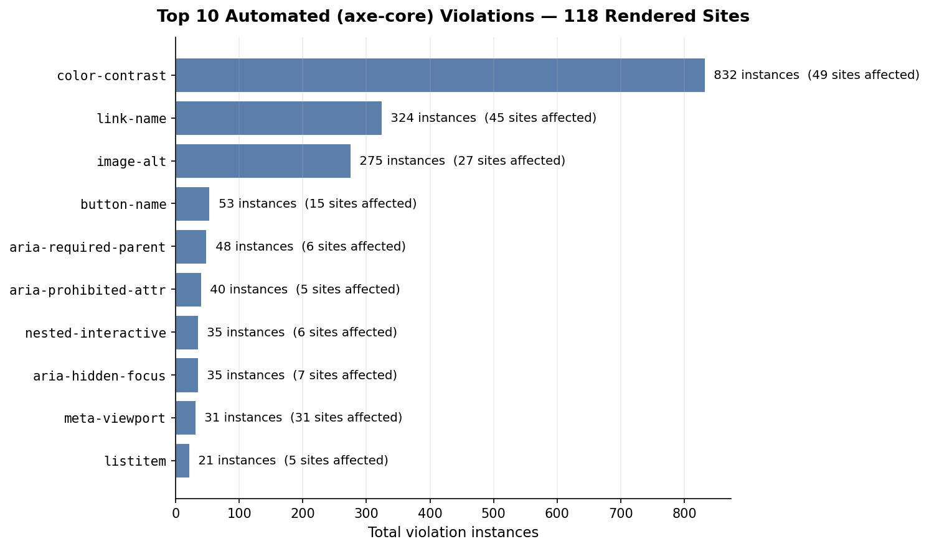
- Colour contrast (832 instances across 49 sites): text fails the WCAG AA contrast ratio of 4.5:1, or 3:1 for large text. This is the most prevalent issue in the dataset, and the easiest to remediate via a stylesheet audit.
- Link name (324 instances across 45 sites): links lack discernible text. The most common causes are icon-only links without aria-labels and social media icons in footers. Screen readers cannot describe these links to users.
- Image alt (275 instances across 27 sites): informative images missing alt text. Concentrated in a small number of image-heavy sites where remediation is large in scope but mechanical.
Together, these three issue classes account for over 80% of detected automated violations. They are also the issues a regulator is most likely to detect when running an automated scan in response to a complaint.

7. Accessibility overlays
Ten of the 160 sites in the audit had a third-party accessibility overlay widget installed. These products are widely marketed to non-technical site owners as a low-effort EAA compliance solution. The European disability community has consistently rejected this framing: overlays cannot fix underlying code-level issues like missing alt text, broken heading hierarchy, or inaccessible custom components. They can only modify visual presentation for users who interact with the overlay itself.
Overlay-equipped sites in this audit scored no better on average than non-overlay sites in the same sector. Three of the ten overlay-equipped sites had detectable underlying issues that the overlay was actively masking. In one example, the overlay claimed conformance in its boilerplate statement while axe-core detected critical violations on the same page.

What this means for Portuguese organisations

For organisations that scored well
A composite score in the A or B band indicates deliberate accessibility work and a published statement. It does not indicate full conformance. Organisations in this band should:
- Commission a full manual conformance audit before the EAA enforcement window matures further. Automated tooling typically catches 30–40% of WCAG issues; the rest require human evaluation.
- Verify that the published accessibility statement reflects the current state of the site, not the state at the time of writing. Statements should be reviewed at least annually.
- Establish a complaints handling procedure that meets the Article 13 timelines, and publish the responsible feedback channel where users can find it.

For organisations that scored in the C or D band
A score in this band typically means some accessibility work has been done, but without a coherent compliance posture. The common pattern is a site that passes mobile viewport and language checks (often by framework default) but lacks structural landmarks, has heading-order issues, and has no published statement. For these organisations:
- The fastest single intervention is publishing an Article 13 accessibility statement. It is required by law, it is mechanically straightforward, and it moves an organisation from "no engagement" to "documented engagement" in a regulator's eyes.
- Cookie banner accessibility is the second-fastest material improvement. The banner is a discrete component, often supplied by a third-party CMP that has accessible variants available.
- Colour contrast remediation typically delivers the largest reduction in automated violation counts for the lowest engineering effort.

For organisations that scored in the F band or were not reachable
These sites are at the highest risk of regulatory attention. An unreachable site is, in practice, also unreachable to assistive technology in many configurations. A site scoring in the F band would not survive any reasonable manual audit, and is likely to receive complaints if anyone chooses to file one with the relevant regulator.
- A formal accessibility audit by a qualified consultant is the appropriate first step for organisations in this position. Self-remediation is unlikely to succeed at the scale required.
- Site infrastructure that blocks bots will frequently also block legitimate accessibility tooling, including the tools regulators use during investigations. Whitelisting known accessibility scanners is a low-risk infrastructure change.

Sector-level observations
Beyond individual organisations, several patterns emerge at the sector level:

Banking outperforms but does not excel
Banking achieved the highest mean score, in line with the sector's long history of investment in regulated digital infrastructure. The gap between Banking's 12.1/20 and a genuinely strong sector-wide score (anything approaching 16/20) remains substantial. Three banking sites in the audit could not be reached at all.

Public Sector shows the legacy of WAD compliance work
Portuguese public sector sites have been subject to the Web Accessibility Directive transposition (Decreto-Lei 83/2018) for almost eight years, longer than the EAA. The 11.6/20 mean reflects accumulated compliance investment, particularly visible in the higher prevalence of accessibility statements among public sector sites. The remaining gap is concentrated in older municipal and ministerial portals that have not been refreshed since the original WAD work.

Utilities and Sport & Culture lag substantially
These two sectors share a profile: lower digital sophistication overall, customer interactions that historically did not require sustained website use, and limited competitive pressure on user experience. As a result, accessibility provision in these sectors is meaningfully behind. The customer base also skews older and includes a higher proportion of users who would benefit most from accessibility provision.

E-commerce shows the highest unreachable rate
Seven of the twenty E-commerce sites in scope could not be reached by the automated audit. The unreachable rate is significantly higher than any other sector, and reflects aggressive bot-blocking infrastructure deployed by larger Portuguese retail platforms. The infrastructure protects against scraping but also blocks accessibility tooling, third-party audit work, and in some configurations certain assistive technologies that simulate browser behaviour.

Looking ahead
The European Accessibility Act has been enforceable for ten months at the time of this audit. The dataset shows that compliance work has begun in pockets but has not yet reached the operational level in most Portuguese organisations. The accessibility statement gap (58% of sites with no detectable statement) is the most actionable finding: it is the easiest individual element to remediate, and the element regulators will look for first.
Enforcement patterns to date in other EU member states (notably Germany, France, and Italy) show first-wave regulatory action focused on the most visible categories (large e-commerce platforms, banks, and telecoms) and on the easiest-to-prove failures, including missing accessibility statements and obvious axe-detectable issues like colour contrast and missing alt text. Portuguese enforcement will likely follow a similar pattern.
accessibilityref.eu will repeat this audit in September 2026 (mid-year update) and January 2027 (year-end review), with comparable methodology and scope. A second comparable dataset will allow trend reporting: which sectors are improving, which are not, and where regulator attention may be most warranted.
The State of Portuguese Digital Accessibility report is published as a recurring series. Aggregate findings are public; individual results are not. The objective is to inform the conversation, not to identify defendants.

About this report
This report was produced by accessibilityref.eu, an independent European accessibility tooling and reference platform. The audit ran between 22 and 24 April 2026 on a custom Node.js audit harness combining HTTP fetching, headless browser rendering, axe-core 4.10, and a purpose-built Article 13 accessibility statement classifier.
The anonymised dataset is published as an Excel workbook alongside this report (state-of-portuguese-digital-accessibility-2026-dataset.xlsx). The workbook contains the per-site composite scores, axe-core violation counts, statement verdicts, and the twenty binary check results. Site identities are masked using sector-prefixed sequence identifiers (e.g. BANK-01, ECOM-12) ordered by composite score within each sector. No mapping between anonymous identifiers and named entities is published.
Methodology questions, data extracts beyond the published workbook, and feedback from named organisations seeking their own scorecard should be directed to press@accessibilityref.eu. The founder is available for written comment in English and Portuguese; spoken interviews are available in English only.
© 2026 accessibilityref.eu. This report may be cited and quoted with attribution. The underlying dataset is provided under a transparent research framing and may not be used to identify individual organisations.

